Report For Fiori Client Basic
Understanding

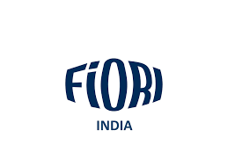
FIORI Concrete Machines India Pvt. Ltd.
About
- The company manufactures and supplies advanced concrete mixing solutions including the DBX (X-Generation) and DBS series of self-loading mixers, designed for efficiency, safety, and ease of use.
- FIORI’s products are widely recognized for enabling on-site, on-demand concrete production, reducing costs and environmental impact.
- FIORI Concrete Machines India Pvt. Ltd. focuses on quality, innovation, and customer support, aiming to deliver reliable construction equipment while maintaining international standards.
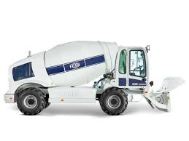

Establishment & Ownership
- FIORI Concrete Machines India Pvt. Ltd. is a 100% wholly owned subsidiary of Fiori Group S.p.A., Italy, established in March 2022 in India.
- They pioneered the concept of the Self-Loading Mixer (SLM) in 1965, introducing innovative features such as the swivel drum.
- The Chennai facility is the only Fiori manufacturing plant outside Italy, located near Irungattukottai, Sriperumbudur, Tamil Nadu. It spans approximately 3 acres with 65,000 sq ft of covered production, sub-assembly, and spare parts storage space.

Available Models :
FIORI India manufactures a concise lineup of self-loading mixers tailored for the local market and global standards, including:
Front-Loading Mixers (DBX Series):
- DBX 2500 and DBX 5000, representing the compact and efficient "X-Generation" line introduced in 2014 .
Rear-Loading Mixer (DBS Series):
- DBS 4300, following FIORI's long-standing design legacy dating back to the 1960s .
Online catalog confirms that three product models are actively offered:
- Front Loading Mixer DBX 5000
- Front Loading Mixer DBX 2500
- Rear Loading Mixer DBS 4300

Market Presence & Application:
FIORI machines have been operating in India for over 25 years, demonstrating strong market presence and recognition FIORI Concrete Machines India.
Key application segments include:
- Concrete supplying
- Irrigation & water management
- Energy generation/distribution
- Government and military infrastructures
- Urban infrastructure and municipalities
- Foundations, railways, roads, tunnels, mining.
Model | Loading Type | Key Characteristics
DBX | Front-loading | Compact, X-Generation, high visibility
DBS | Rear-loading | Mobile, flexible, suitable for batching replacement

Summary.
FIORI Concrete Machines India Private Limited – Brief Overview
- Company Name: FIORI Concrete Machines India Private Limited
- Industry: Construction / Concrete Machinery
- Description: FIORI specializes in manufacturing and supplying concrete machinery, including mixers, pumps, and transit mixers, providing innovative solutions for construction and infrastructure projects.
- Key Focus: Innovation, reliability, and sustainable concrete solutions.
- Global Presence: Operates in multiple countries with after-sales support and technical services.
- Popular Machines: Concrete mixers, concrete pumps, transit mixers, and auxiliary equipment.
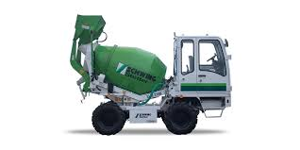

Front Loading Mixer DBX 5000
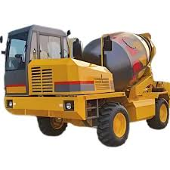

Front Loading Mixer DBX 2500

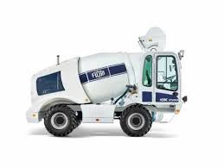

Rear Loading Mixer DBS 4300
Conclusion :

- FIORI Concrete Machines India Private Limited has established itself as a significant player in the concrete machinery industry.
- The company is recognized for its dedication to innovation and quality.
- It continues to offer reliable and advanced solutions for diverse construction needs.
- FIORI has successfully combined technology with practical applications, ensuring high efficiency and performance.
- Their machinery is known for durability and precision, catering to both small and large-scale projects. The company maintains a strong focus on sustainable construction practices.
- FIORI’s global presence highlights its ability to adapt and compete in international markets.
- Their after-sales service and technical support reinforce customer confidence. The company invests continuously in research and development to stay ahead of industry trends.
- FIORI has built a reputation for reliability and trustworthiness. Their product range addresses multiple aspects of concrete production and transportation.
- They emphasize safety and operational excellence.
- FIORI’s approach to innovation ensures solutions are user-friendly and cost-effective.
- Collaboration with construction professionals enhances their product design. The company’s vision includes expanding its reach and adopting emerging technologies.

